110 Q2 SAT 7/2 Sec**_**Student**ID** ___________ **Name in CAPITAL** _______________________

You can use pencil / pen / both. Pencil users cannot report problems/mistakes in checking this quiz paper when it will be returned back to you after checking. Forgetting to fill above blanks means, you are absent. You can use the other side of the pages as well for any of your answers if you need more space.

* Do not overwrite, instead cross-out/strikethrough ~~like this~~ and write again.
* Understanding the question is part of the exam. Manage space well/use column, no extra page will be given

**Q1) Write alternative words for the followings:**

|  |  |
| --- | --- |
| **Word** | **Alternative word(s)** |
| **START** |  |
| **STOP** |  |
| **READ** |  |
| **PRINT** |  |
|  |
|  |
|  |

**Q2) Draw the smallest flowchart possible. Hint: It is the skeleton / dummy that does not do any work.**

**Q3 Draw flowchart of program that takes** *age***from the user and prints it. For example, if the user gives 7, then the program should print 7.**

**Q4) Draw flowchart of program that takes a** *year* **from the user. Tells if it is present, past or future. For example, if the user gives 2013, your program should print “past”.**

**Expected output:**

Eid Mubarak

Eid Mubarak

**Q5) Draw flowchart of program that prints the message “Eid Mubarak” two times, one after another.**

|  |  |
| --- | --- |
| **Military Time (input)** | **Civil Time (Output)** |
| **1** | **1 BT** |
| **2** | **2 BT** |
| **3** | **3 BT** |
| **4** | **1 MT** |
| **5** | **2 MT** |
| **6** | **3 MT** |
| **7** | **1 PT** |
| **8** | **2 PT** |
| **9** | **3 PT** |
| **10** | **4 PT** |
| **11** | **5 PT** |
| **12** | **6 PT** |

**Q6) In planet** **Barzakh, each day is 12 hours (NOT 24) and time conversion table is below. Ask user for military time and then print time in civil time e.g., if the user gives 6 as input, print “3 MT” as output. Do NOT use more than three/four “PRINT” boxes.**

|  |  |
| --- | --- |
| **CGPA (Input)** | **Award (Output)** |
| **below 2** | **Fail** |
| **2 to 3.49** | **Pass** |
| **3.5 to 3.64** | **Distinction** |
| **3.65 to 3.79** | **High Distinction** |
| **3.8 or above** | **Highest Distinction** |

Q7) Draw **two different flowchart** of a program that asks the user for CGPA as input and then prints the award message. Do NOT use more than seven “**print/output”** boxes**. If the user inputs any CGPA outside the range 0🡪4, print “invalid”.**

Example1: If user gives 3.6 as input, then print “Distinction” as output.

Example2: If user gives 1.5 as input, then print “Fail” as output.

Example3: If user gives **-** 4 as input, then print “Invalid” as output.

Example4: If user gives 9 as input, then print “Invalid” as output

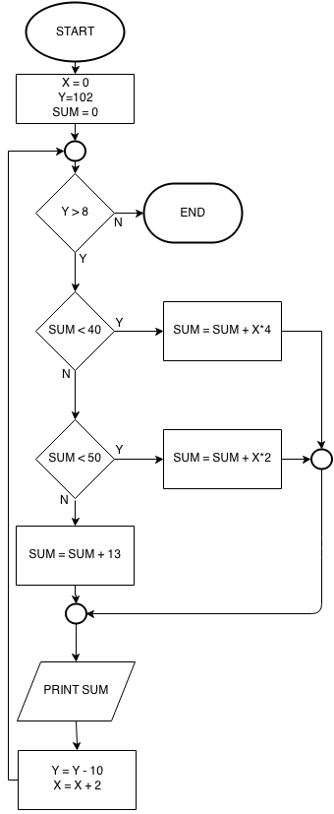

#### 

**Q8) Find output of the flowchart**:

There may be more or less output boxes



than necessary. Draw more if needed.

Write output on the question paper

**OUTPUT:**

|  |
| --- |
|  |
|  |
|  |
|  |
|  |
|  |
|  |
|  |
|  |
|  |
|  |

in the boxes given below:

A = A + 2

SUM =

SUM + 2A + 3

SUM =

SUM + 4A + 5